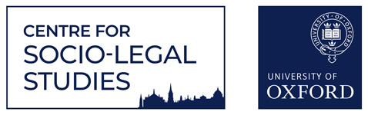

Socio-Legal Discussion Group
Michaelmas Term 2022
Thursdays 12.30 – 2.00pm
Seminar Room B, Manor Road Building

Week 1: 13th October
Vaccine Opposition in the Information Age: A Study on Online Activism and DIY Citizenship
Francesca Uberti, CSLS postdoctoral researcher
https://us02web.zoom.us/j/84400895308?pwd=SFpNenFEYjlEMzBTdVkvSkNXOTFUdz09

Week 3: 27th October
Education, Development and Democratic Transition
Richard Dolan, DPhil student, Development Studies

Zoom link: https://us02web.zoom.us/j/84400895308?pwd=SFpNenFEYjlEMzBTdVkvSkNXOTFUdz09

Week 5: 10th November
Masculinity, Violence and the Denial of Victimhood: Understanding the Construction of Victimhood in Gay Intimate Partner Violence
Joseph McAulay, , CSLS postdoctoral researcher

Zoom link: https://us02web.zoom.us/j/84400895308?pwd=SFpNenFEYjlEMzBTdVkvSkNXOTFUdz09

Week 8: 1st December
Intersections of Climate Change Adaptation, Migration, and Public International Law
Lauren Nishimura, DPhil student, Law

Zoom link: https://us02web.zoom.us/j/82310305437?pwd=dGdRNCtpN3Z2NGRUVk8yREtUeEs4Zz09

Convened by the CSLS Student Reps: studentrep@csls.ox.ac.uk

